Intro
In modern data-driven systems, reliable and timely information is critical for accurate processing and decision-making. In the context of sports match data processing, input quality directly impacts output integrity.
Currently, the system relies solely on a single predefined feed — Base_feed — to update match data during each iteration. While this approach ensures consistency, it creates a single point of failure and limits flexibility. If Base_feed becomes unavailable or delayed, the system cannot utilize data from other available sources, even if they provide timely and accurate updates.
To improve resilience, data freshness, and operational control, it is essential to introduce a dynamic selection mechanism based on configurable priorities. This allows administrators to define a preferred order of external feeds according to reliability, latency, or business requirements.
The goal of this task is to design and specify a Feed Priority tool that enables system administrators to:
- Define a custom priority list of external data feeds
- Test individual feed connectivity before activation
- Enable the system to select the highest-priority feed with available data during each iteration
This enhancement will transform the system from a static, single-source model into a more adaptive and robust solution, capable of handling real-world variability in data availability while maintaining full user control over source preferences.

Functional and Non-Functional Requirements
1. Functional Requirements
FR-01. Priority List Management
- The system shall allow adding external feeds to the priority list from the pool of available sources.
- Each feed may appear in the list only once.
- Users shall be able to remove a feed from the list; upon removal, the feed returns to the available pool.
FR-02. Reordering Priorities
- The administrator shall be able to change the order of feeds via drag-and-drop.
- The first item in the list has the highest priority, with subsequent items decreasing in priority.
FR-03. Configuration Saving and Application
- The configuration shall be saved to the database (PostgreSQL) after clicking "Save".
- Changes take effect at the start of the next iteration (within ≤1 minute).
- The system shall block saving if the list is empty.
FR-04. Feed Connectivity Testing
- Each feed in the interface shall have a "Test" button.
- On click, the system sends a diagnostic request to the feed.
- The result shall be displayed as: "Available", "Unavailable" or "High latency".
- For successful responses, a data preview (first 100 characters) shall be shown.
FR-05. Input Validation
- The system shall validate that all feed names in the list correspond to existing sources.
- If an invalid configuration is attempted, an error message shall be displayed.
FR-06. Fallback Behavior
- If no user configuration exists or it is invalid, the system shall use the default fallback: Base_feed.
- This ensures uninterrupted operation.
FR-07. Action Logging
- All configuration changes shall be logged: who changed what and when.
- Each feed selection during an iteration shall be logged with timestamp and feed name.

2. Non-Functional Requirements
NFR-01. Performance
- UI response time for user actions — no more than 1 second.
- Test requests to feeds must complete within 3 seconds (timeout).
- The feed selection algorithm shall execute in less than 100 ms per iteration.
NFR-02. Reliability
- Configuration data shall be protected against loss (via PostgreSQL backup).
- The system shall continue operating even if one or more feeds are temporarily unavailable.
NFR-03. Security
- Access to the "Feed Priority" section shall be restricted to users with Admin role.
- All actions shall be audited; logs shall be retained for at least 90 days.
NFR-04. Scalability
- The solution shall support increasing the number of external feeds up to 20 without redesign.
- The interface shall display correctly for any number of feeds from 1 to 20.
NFR-05. Usability
- The interface shall be intuitive for administrators without technical training.
- Keyboard navigation shall be supported (for accessibility compliance).
- Error messages shall be clear, in plain language, and include guidance for resolution.
NFR-06. Compatibility
- The tool shall integrate seamlessly with the existing minute-by-minute data processing cycle.
- The configuration shall be readable by the feed selection component.
NFR-07. Maintainability
- Code shall be accompanied by documentation (API description, DB schema).
- Configurations shall be portable across environments (dev, staging, prod).

UI Requirements
1. Overall Interface Layout
UI-01. Page Structure
- The page is divided into two columns:
Left column: "Available Feeds" — list of all 10 external data sources
Right column: "Priority List" — ordered list of selected feeds
- Page title: "Feed Priority Configuration"
- Action buttons: "Save", "Reset"

2. Control Elements
UI-02. Adding a Feed
- A feed can be added by:
Drag-and-drop from the left to the right column
Clicking the "+" button next to the feed name
- After adding, the feed disappears from the available list
UI-03. Removing a Feed
- Each item in the priority list has a remove button (× icon)
- On click, the feed is removed and returned to the available pool
UI-04. Reordering
- Drag-and-drop functionality implemented in the priority list
- During drag, a semi-transparent preview and drop zone are displayed
- The first item in the list has the highest priority
UI-05. Connectivity Testing
- Each feed (in both lists) has a "Test" button
- On click:
Button becomes disabled with a loading indicator
Within ≤3 seconds, result is displayed:
Green indicator + "Available"
Red indicator + "Unavailable"
Yellow indicator + "High latency"
For successful responses, a collapsible block shows data preview (first 100 characters)

3. State Visualization
UI-06. Priority Display
- Items in the right column are numbered:
- Number indicates priority level (1 = highest)
UI-07. Save Status
- The "Save" button:
Enabled only if at least one feed is in the priority list
Shows "Saving..." on click, followed by success or error message
- On success: toast notification "Configuration successfully applied"
UI-08. Error Handling
- If attempting to save an invalid configuration:
A red message appears below the list: "Add at least one feed to the priority list"
The problematic field is highlighted with a border

4. Additional Requirements
UI-10. Tooltips
- On hover over the help icon (?) near the title, show tooltip:
"Here you can configure the order in which the system checks external data feeds. On each iteration, the first available feed from this list will be selected."

User story
US-1: Base User Story
As a System Administrator
I want to create and edit the priority list of external data feeds
So that the system uses the most reliable or up-to-date sources first when processing sports match data
Acceptance Criteria
1. Managing the priority list
- The user can add any of the available 10 external feeds to the priority list
- A feed can be added only once
- The user can remove a feed from the list
- After removal, the feed becomes available for re-adding
2. Reordering priorities
- The user can change the order of feeds via drag-and-drop
- The first item in the list has the highest priority
- The new order is automatically saved in the interface after rearrangement
3. Configuration validation
- Saving an empty list is not allowed
- Attempting to add a non-existent feed shows an error: "Feed not found"
- The system validates all feed names before saving
4. Saving and applying configuration
- The configuration is saved upon clicking the "Save" button
- Changes take effect at the start of the next iteration
- A confirmation message is displayed: "Configuration successfully applied"
5. Visualizing current state
- The active list is displayed as a numbered list
- All available feeds are shown separately in the interface

US-2: Testing external feed connectivity
As a System Administrator
I want to test each external feed in the list
So that I can verify its availability and integration correctness
Acceptance Criteria:
- Next to each feed in the UI there is a "Test" button
- On click, the system sends a test request to the feed
- The result is displayed as:
"Available" — if the feed responds within timeout (e.g., 3 sec)
"Unavailable" — if no response or connection error
"High latency" — if response time exceeds threshold (e.g., >2 sec)
- For successful responses, a data preview is shown
- Testing does not affect the main data processing cycle
- Results are stored temporarily (cleared on page reload)
Technical Notes:
- Uses the same integration logic as real data collection
- Tests only connectivity, does not trigger full processing
- A dedicated diagnostic endpoint is used for testing

US-3: Fallback behavior
As a System Operator
I want the system to fall back to Base_feed if no configuration exists
So that data processing continues without interruption
US-4: Feed selection logging
As a System Administrator
I want to see which feed was selected on each iteration
So that I can troubleshoot data issues
US-5: Feed performance monitoring
As a Data Analyst
I want statistics on how often each feed provides data
So that I can optimize the priority list

Technical Notes
- The interface will be implemented as part of the admin panel
- Configuration is stored in the database
- The feed selection algorithm uses the updated list on every iteration
- Integration with the existing data processing cycle

Use case
Use Case: "Configure and Test External Feed Priorities"

Use Case ID: UC-01
Title: Configure and test priority of external data feeds
Actor: System Administrator
Goal: Set the priority order for external data sources and verify their availability before activation
Priority: High
Type: Primary

Brief Description
The administrator configures the priority order of external data feeds used by the sports match processing system. Additionally, they can test each feed individually to confirm connectivity and integration correctness before saving the configuration.

Preconditions
- The administrator is authenticated in the system
- The administration interface is available
- The list of 10 external feeds is loaded into the system

Main Scenario (Happy Path)
Step | Actor Action | System Response
1 | Opens the "Feed Priority" section | Displays the feed priority management interface
2 | Drags a feed from the available list into the priority list | The feed is added to the priority list with its position indicating priority level
3 | Clicks the "Test" button next to a feed | The system sends a diagnostic request to the feed
4 | Waits for the result | Displays status:  "Available"  "Unavailable"  "High latency"  Plus a preview of received data (first 100 characters) if successful
5 | Repeats steps 2–4 for all required feeds | All selected feeds appear in the priority list, reorderable via drag-and-drop
6 | Clicks "Save" | The system validates the list:  — No empty or invalid feed names  — At least one feed is present
7 | Confirms save action | The system saves the configuration to the database and displays: "Configuration successfully applied"  Changes take effect at the start of the next iteration

Alternative Scenarios
A1. Attempt to save an empty list
Condition: User clicks "Save" with no feeds in the priority list
System: Disables the "Save" button or shows error: "Add at least one feed to the priority list"
A2. Attempt to add a non-existent feed
Condition: Manual input contains a name not in the known list
System: On attempt to add — shows error: "Feed 'XXX' not found"
A3. Testing an unreachable feed
Condition: Feed does not respond within 3 seconds after "Test" click
System: Shows status: "Unavailable" with suggestion: "Check connection or contact integration team"
A4. High response latency from feed
Condition: Feed responds but takes longer than 2 seconds
System: Shows status: "High latency", warning that this feed may slow down processing

Postconditions
- The priority configuration is saved in PostgreSQL
- The feed selection algorithm uses the updated order starting from the next iteration
- An audit log records: "Feed Priority configuration updated by user [ID]"

Algorithm
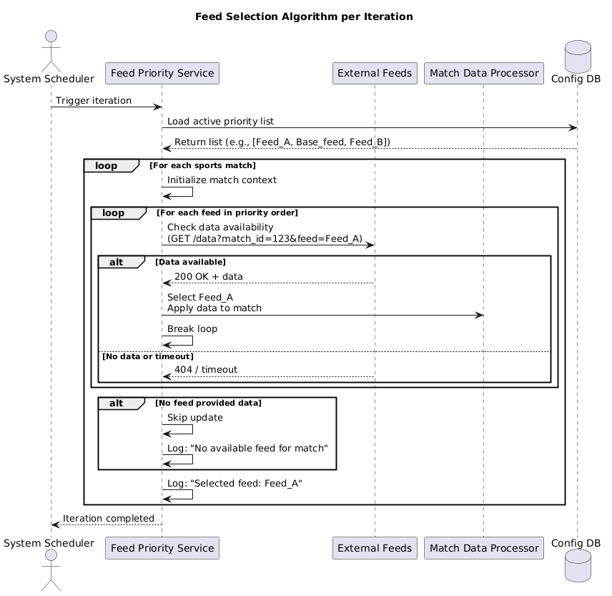
Textual Description of the Algorithm
On each iteration, the system performs the following steps to select an external feed:
- Retrieve Active Configuration
The system loads the current priority list from the database. If no configuration exists, it uses the default: [Base_feed].
- Check Feed Availability
For each sports match, the system checks which of the configured feeds currently provide data. This is done in parallel or sequentially, depending on integration setup.
- Iterate Through Priority List
Starting from the top of the priority list:
  - Check if the feed has available data for the match
  - If yes → select this feed and stop the search
  - If no → proceed to the next feed in the list
- Handle No-Available-Feed Case
If none of the feeds in the priority list have data:
  - Do not apply any updates to the match
  - Log event: "No available feed found"
  - Wait for the next iteration
- Apply Data & Finalize
Once a feed is selected:
  - Retrieve full data from the chosen feed
  - Apply it to the sports match record
  - Log selection: Selected feed: [Feed_Name]
  - Complete the iteration

This algorithm ensures that the most reliable available source is used while maintaining user-defined control over preference order.

API
1. Overview
The API allows managing feed priority configurations and checking external feed status. All endpoints are accessible only to users with Admin role.
Base URL:
https://api.system.com/v1/feed-priority
Data Format:
- Requests and responses use JSON
- Encoding: UTF-8
- Authentication: Bearer Token

2. Endpoints
GET /config
Retrieve current priority configuration
Response (200 OK)
{
"priority_list": [
"Feed_A",
"Base_feed",
"Feed_B"
],
"updated_at": "2026-03-26T14:30:00Z",
"updated_by": "admin@Altenar.com"
}
Possible Errors:
- 404 Not Found — no configuration exists
- 403 Forbidden — insufficient permissions

POST /config
Save new priority configuration
Request Body:
{
"priority_list": ["Feed_A", "Base_feed", "Feed_C"]
}
Validation Rules:
- List must not be empty
- All names must match existing feeds
- No duplicates allowed
Response (201 Created):
{
"status": "success",
"message": "Configuration saved successfully",
"applies_at": "2026-03-26T14:31:00Z"
}
Errors:
- 400 Bad Request — invalid format or unknown feed names
- 403 Forbidden — write access denied

GET /feeds
Get list of all available external feeds
Response (200 OK):
{
"available_feeds": [
"Feed_A",
"Feed_B",
"Feed_C",
"Base_feed",
"match_TV",
"SportStream_7",
"LiveStats_Pro",
"GlobalScore",
"EventFlow",
"TimeSync_API"
]
}

POST /feeds/test
Test connectivity to one or more external feeds
Request Body:
{
"feeds": ["Feed_A", "Base_feed"]
}
Response (207 Multi-Status):
{
"results": [
{
"feed": "Feed_A",
"status": "available",
"response_time_ms": 142,
"sample_data": "{\"match_id\":123,\"score\":\"2:1\"}"
},
{
"feed": "Base_feed",
"status": "unavailable",
"error": "timeout",
"response_time_ms": 3000
}
]
}
Status Descriptions:
- "available" — successful response within ≤2 sec
- "high_latency" — response time between 2–3 sec
- "unavailable" — timeout (>3 sec) or connection error

GET /status
Health check endpoint
Response (200 OK):
{
"service": "feed-priority-service",
"status": "healthy",
"version": "1.2.0",
"last_updated": "2026-03-26T14:30:00Z"
}

